HD Analog Day/ Night Vari-Focal IR Dome Camera

CV-CFW101L
CV-CFW101LN

• Installation Guide ........................................... 1 pc.
• Screw …………………………………………… 2 pcs.
• Screw plug ……………………………………... 2 pcs.
Smart look Day/ Night Vari-Focal Dome Camera with IR illuminator
illuminator
illuminator
Parameter | CV-CFW101L | CV-CFW101LN
Camera
Image Sensor | 1/2.9" 1.0 Mega Pixels CMOS
Effective Pixels | 1280 (H) x 720 (V)
Min Illumination | 0.05Lux/ F1.4, 0Lux IR on
Electronic Shutter | 1/50s~1/100,000s | 1/60s~1/100,000s
Video Frame Rate | 25fps | 30fps
Synchronization | Internal
Day & Night | Auto (ICR)/ Color/ B/W
Max IR Distance | 30m
Digital Noise Reduction | 2D
White Balance | Auto
AGC | Auto
BLC | Auto
Lens
Focal Length | 2.7-12 mm @ Manual/ Fixed Iris
Angular Field of View | H: 35$°(Tele)$ ~ 93$°(Wide)$  V: 21$°(Tele)$ ~ 50$°(Wide)$
Lens Type | Φ14
Input / Output
Video Output | 1 CH BNC HD-CVI video output
General
Power | DC 12V±25%
Power Consumption | 2.8W MAX
Working Temperature | -30℃~+60℃.  Less than 95% RH (no condensation)
Dimensions | Φ119 mm × 97.4 mm
Weight (approx.) | 550g
Installation Mode | Wall mount/ In-ceiling mount
External Case | Metal
Specifications
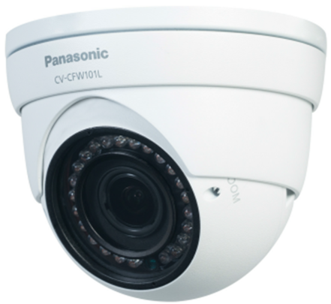

• Installation Guide ........................................... 1 pc.
• Screw …………………………………………… 2 pcs.
• Screw plug ……………………………………... 2 pcs.
Key Features
- High-performance CMOS image sensor.
- Support 720p@25fps (PAL)/ 30fps (NTSC).
- Support 75-3 coaxial cable transmission over 800m.
- High speed & long distance real-time transmission.
- Support ICR for day time and night time operation.
- Support auto exposure, auto white balance, auto electronic shutter and auto gain function.
- High image color rendition, vivid image.
- Support manual adjustment of lens zoom and focus.
- Support DC12V power supply.
- IP66 compliance.

Standard Accessories
- Quick guide……………………....1 pc
- Important safety instruction…….1 pc

Appearance
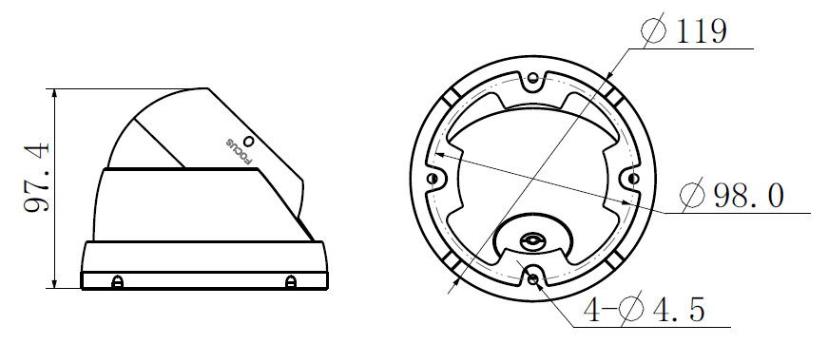
Important
- Safety Precaution: Carefully read the operating instruction manual before using this product.

DISTRIBUTED BY:
- All pictures are simulated.
- Weights and dimensions are approximate.
- Specifications are subject to change without notice.
- These products may be subject to export control regulations.
• Installation Guide ........................................... 1 pc.
• Screw …………………………………………… 2 pcs.
• Screw plug ……………………………………... 2 pcs.
• Installation Guide ........................................... 1 pc.
• Screw …………………………………………… 2 pcs.
• Screw plug ……………………………………... 2 pcs.
• Installation Guide ........................................... 1 pc.
• Screw …………………………………………… 2 pcs.
• Screw plug ……………………………………... 2 pcs.
• Installation Guide ........................................... 1 pc.
• Screw …………………………………………… 2 pcs.
• Screw plug ……………………………………... 2 pcs.
• Installation Guide ........................................... 1 pc.
• Screw …………………………………………… 2 pcs.
• Screw plug ……………………………………... 2 pcs.
• Installation Guide ........................................... 1 pc.
• Screw …………………………………………… 2 pcs.
• Screw plug ……………………………………... 2 pcs.
• Installation Guide ........................................... 1 pc.
• Screw …………………………………………… 2 pcs.
• Screw plug ……………………………………... 2 pcs.

